ST. JOSEPH’S COLLEGE (AUTONOMOUS)

36, Lalbagh road, Bangalore – 560027

DEPARTMENT OF COMPUTER SCIENCE (UG)
BSC PROGRAMME



DEPARTMENT DOCUMENTATION MANAGEMENT SYSTEM
Project Report submitted in fulfilment of the requirements for the award of the degree of

BACHELOR OF SCIENCE(BSC)
A Project by:
RAJESH .M - 21MEC04
R.M. LENNIN DOCRAS – 21MEC06
SUMAN SUDHAGAR – 21MEC12
ABDUL RAHMAN.N– 21MEC40

Under the guidance of
Prof. JOY KEREN
Prof. BOJAMMA


DEPARTMENT OF COMPUTER SCIENCE (UG)

CERTIFICATE OF COMPLETION

This is to certify that the practical lab for the course titled “Department Documentation Management System” has been satisfactorily completed by Rajesh.M-21MEC04, Lennin Docras R.M.- 21MEC06, Suman Sudhagar- 21MEC12, Abdul Rahman- 21MEC40 in partial fulfilment of the award of the Bachelor of Computer Applications degree requirements prescribed by St Joseph’s University, Bengaluru, during the academic year 2023-2024.

Internal Guide Head of the Department

Valued by Examiners
1:_____________________ Place:

2: ____________________ Date:

DECLARATION

We, Group 11, hereby declare that the practical lab work for the course titled “Department Documentation Management System” has been completed by me, as per the course guidelines, under the guidance of Prof. Joy Keren and submitted. Rajesh.M-21MEC04, R.M. Lennin Docras- 21MEC06, Suman Sudhagar- 21MEC12, Abdul Rahman- 21MEC40 has worked on it and completed this project. This report work has not been submitted earlier either to any University / Institution or any other body for the fulfilment of the requirement of a course of study.

Location:
Date:

ACKNOWLEDGEMENT

The completion of the project gives me immense happiness and satisfaction by providing me with an opportunity to express my gratitude to everyone who has played an important role in supporting me in my venture, and I would also take a step ahead to thanks everybody else who inspired my actions and work.

First of all I would like to thank Dr.Fr. VICTOR LOBO our principal of St Joseph’s College, for a chance that he has given us in the college for research on this project.

I would also like to express our sincere thanks to prof. Joy Keren for guiding us in the whole process and Prof. Prashanti Head of the Department of computer science, who has always been a constant source of inspiration and enlightenment.

Lastly, I would like to express my gratefulness to my parents and friends for having shown their trust and faith in me and boosting my morals constantly I am grateful to God for his blessings which helped me to complete this project smoothly.

TABLE OF CONTENTS
SL. NO. | Topic | Pg no
1  2  3  4  5  6  7  8  9  10 | Abstract  Introduction  Study of Proposed System.  Analysis  Design  Testing strategies  Coding  Future Enhancement  Conclusion  Bibliography | 6  7  8  9  12  15  17  58  60  61

ABSTRACT

The Department Document Management System (DDMS) is a cutting-edge web application developed for the college's computer department, aiming to revolutionize document management practices. Leveraging the XAMPP platform for backend hosting and data management, and utilizing HTML, CSS, and JavaScript for the frontend, the DDMS offers a comprehensive solution for managing various types of documents related to student information, timetable, and syllabus. The system enhances efficiency and effectiveness by replacing traditional paper-based methods with digital solutions, providing a user-friendly interface for accessing and managing documents.
The DDMS represents a pioneering initiative to modernize document management practices within the college computer department. By offering a centralized platform for storing, retrieving, and updating documents, the DDMS streamlines departmental operations and enhances productivity. Prior to the development of the DDMS, the computer department relied on manual methods for managing documents, leading to inefficiencies and delays in document retrieval.

INTRODUCTION

In today's digital age, the management of documents is a critical aspect of organizational efficiency. The DDMS is a pioneering initiative aimed at modernizing the document management practices within the college computer department. The system offers a centralized platform for storing, retrieving, and updating documents, thereby streamlining the department's operations. By replacing traditional paper-based methods with digital solutions, the DDMS is poised to revolutionize document management within the department.
Prior to the development of the DDMS, the computer department relied heavily on manual methods for managing documents. This included maintaining physical records and using traditional filing systems. These methods were not only labour-intensive but also prone to errors and inefficiencies. Moreover, accessing documents required physical presence, leading to delays and hindrances in document retrieval. Design an intuitive and user-friendly interface for document creation, editing, search, and collaboration. Incorporate features such as drag-and-drop functionality, real-time editing, and customizable dashboards to enhance user experience and productivity. Ensure accessibility and responsiveness across different devices and screen sizes.

The proposed DDMS represents a significant advancement over traditional methods. By leveraging XAMPP for backend hosting and data management, the system ensures secure storage and efficient retrieval of documents. The frontend, developed using HTML, CSS, and JavaScript, offers a modern and intuitive interface for users to interact with the system. Additionally, the DDMS includes features such as user authentication and access control, ensuring that only authorized users can access sensitive documents.

STUDY OF PROPOSED SYSTEM

The proposed DDMS represents a significant advancement over the existing system. By utilizing XAMPP for backend hosting and data management, the system ensures the secure storage and efficient retrieval of documents. The frontend, developed using HTML, CSS, and JavaScript, offers a modern and intuitive interface for users to interact with the system. The DDMS also includes features such as user authentication and access control, ensuring that only authorized users can access sensitive documents. Overall, the proposed system is expected to greatly improve the efficiency and effectiveness of document management within the college computer department.

Looking ahead, future enhancements such as integration with AI, enhanced security features, mobile application development, integration with cloud services, advanced collaboration tools, and data analytics capabilities can further enhance the functionality and usability of the DDMS. These enhancements will ensure that the DDMS remains a cutting-edge solution for document management needs, meeting the evolving requirements of the college computer department and enhancing overall organizational efficiency.
Define workflows for document approval, review, and publishing based on organizational policies and regulatory requirements. Implement notifications and alerts to notify users of pending tasks, deadlines, and updates to documents.
Automate routine tasks, such as document archiving and expiration, to streamline document lifecycle management processes.

ANALYSIS

Hardware requirements | Software requirements
- What has been used:  HP laptop with i5 processor, 16GB RAM, 512 SSD, windows 11 operating system  - Required:  - RAM – Minimum – 4.0GB  Maximum –16.0GB  - SYSTEM – Windows 11OS | - Visual studio code 2008  - Php extension  - Html and CSS extensions  - Xampp control panel  - Google document  And excel sheets  - Bootstrap CSS

HARDWARE
- Server:
• Processor: A multi-core processor with sufficient processing power to handle incoming requests and database operations efficiently. A modern processor with multiple cores (e.g., Intel Xeon, AMD Ryzen) would be suitable.
• Memory (RAM): Adequate RAM is essential for smooth performance, especially when handling concurrent users and large datasets. A minimum of 8 GB of RAM is recommended, but the actual requirement may vary depending on the workload. Consider upgrading to 16 GB or more if your application experiences high usage.
• Storage: SSD storage is preferable for faster data access and improved performance compared to traditional HDDs. Ensure sufficient storage capacity to accommodate application files, databases, and any additional data generated by the application.
• Network Interface: A reliable network interface card (NIC) with sufficient bandwidth to handle incoming and outgoing traffic. Consider factors such as network throughput, latency, and scalability to ensure smooth communication between the server and clients.

- Database Server:
• Similar specifications as the server, with additional emphasis on storage capacity and I/O performance to handle database operations efficiently.

- Networking:
• A stable and high-speed internet connection to ensure reliable communication between the server and clients.

- Monitoring and Management:
• Hardware resources for monitoring and managing the server environment, including tools for performance monitoring, security management, and system administration tasks.

- Client Devices:
• Ensure that client devices (e.g., desktops, laptops, tablets, smartphones) meet the minimum requirements for accessing and interacting with the web application. This may include modern web browsers with JavaScript enabled and an internet connection.

SOFTWARE
The software requirements for this project time table management system include both the software components necessary for development and deployment, as well as the software required for end-users to access and interact with the system. Here's a breakdown of the software requirements:
1.Development Environment:
Text Editor or Integrated Development Environment (IDE):
Examples: Visual Studio Code.
Used for writing, editing, and managing code files during development.

2. Web Development Technologies
HTML, CSS, JavaScript: Fundamental languages for building web interfaces and
adding interactivity.
Front-end frameworks/libraries (optional): Such as React.js, AngularJS, Vue.js for
enhancing UI development.
Server-side scripting languages (optional): PHP, Python, Node.js for server-side logic.

3. Database Management System (DBMS):
Example: MySQL, PostgreSQL. • Required for storing, retrieving, and managing data related to timetables, users, courses, etc.

- Development Environment:
- Web Server: 8 • Example: Apache HTTP Server, Nginx.
• Required for hosting and serving the web application to users over the internet.
- Server-side Scripting Environment: • Example: PHP, Node.js.
• Required for executing server-side scripts and handling dynamic content generation.
- Database Server: • Example: MySQL Server, PostgreSQL Server.
• Required for storing and managing application data in a relational database.
4. Operating System: • Windows Server.

- End-User Access:
1. Web Browser: • Examples: Google Chrome, Mozilla Firefox, Microsoft Edge, Safari. • Required for accessing and interacting with the web application's user interface.
2. Internet Connection: • A stable internet connection is required for accessing the web application hosted on the server

DESIGN
System Architecture:
Choose an appropriate architecture, such as client-server or cloud-based, based on scalability, security, and accessibility requirements. Define the components of the system, including the database, application server, and user interface. Determine the communication protocols and data exchange formats between system components. Design the database schema to store documents, metadata, user information, and access control lists. Implement mechanisms for version control, audit trails, and document indexing to facilitate efficient document management and retrieval. Ensure data integrity and security by implementing appropriate encryption, access controls, and backup procedures.

User Interface Design:
Design an intuitive and user-friendly interface for document creation, editing, search, and collaboration.
Incorporate features such as drag-and-drop functionality, real-time editing, and customizable dashboards to enhance user experience and productivity.
Ensure accessibility and responsiveness across different devices and screen sizes.

Search and Retrieval:
Implement advanced search capabilities, including full-text search, filters, and facets, to enable users to quickly locate relevant documents. Integrate with external search engines or indexing services to improve search performance and accuracy. Provide search suggestions, auto-complete, and relevancy ranking to enhance search usability. This part will be advanced in future enhancement

E-R DIAGRAM:

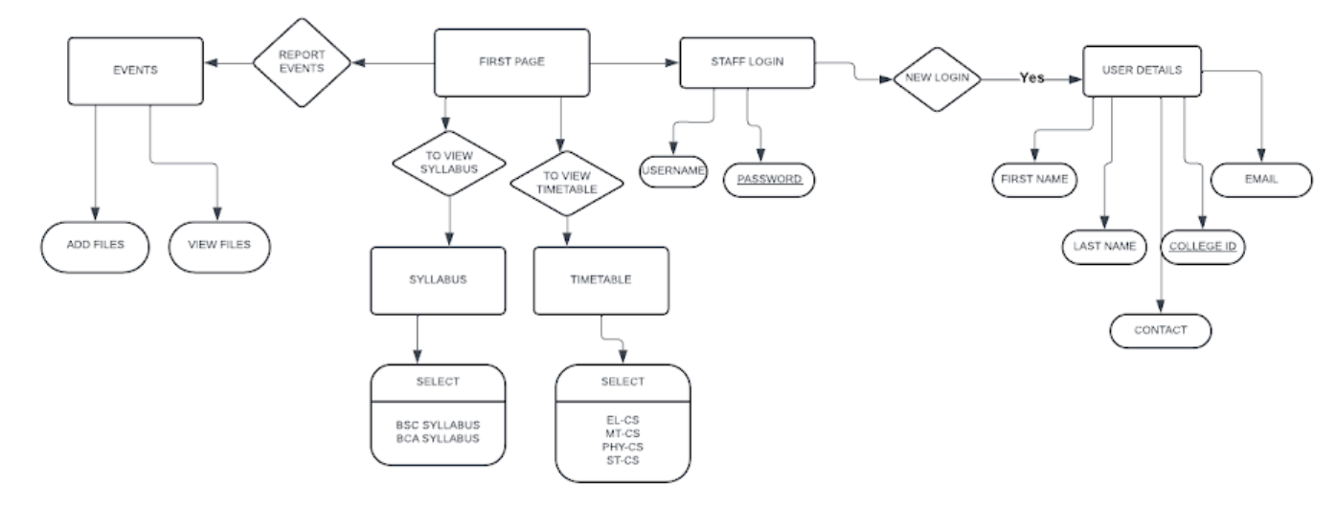

DATAFLOW DIAGRAM: (LEVEL 0)
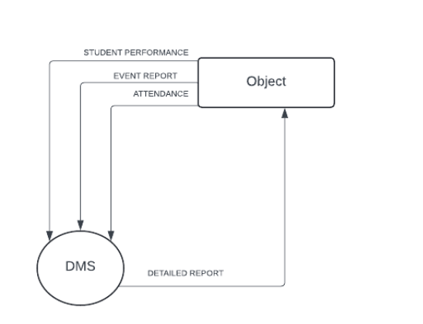
DATAFLOW DIAGRAM: (LEVEL 1)

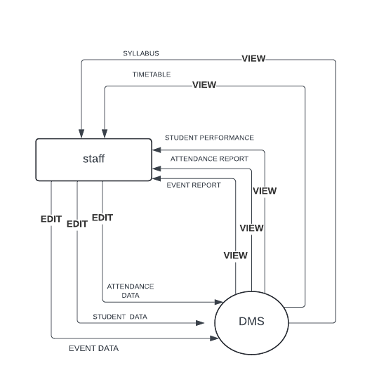
TESTING STRATEGIES

Requirement Review:

Ensure all system requirements are clearly understood and documented before testing begins.
- Laptop with required specifications
- Internet connections
- Xampp control panel
- Visual studio code 2008

Test Planning:

Create a test plan outlining what needs to be tested, including features, functionalities, and use cases. Identify test scenarios and prioritize them based on criticality and frequency of use.
- Use visual studio code to create edit save and run frontend and backend programs
- Once the code is built save it in a folder inside the folder named htdocs in xampps installer software
- After starting server- Apache and database- MySQL in XAMPP software, check whether saved files are getting hosted

Test Case Creation:

Develop test cases for each identified scenario, specifying inputs, expected outputs, and steps to reproduce. Keep test cases simple and focused on one specific aspect of the system. Execute the test cases systematically, following the test plan.

Reporting:
Record the results of each test case, noting any deviations from expected outcomes. Report any defects or issues encountered during testing, including detailed steps to reproduce the problem. Maintain a documentation and update it after every file code success.
Regression Testing:
After fixing reported bugs, test it again. Test all the code files until required output is given out.

CODING
Backend Development:
Create the backend infrastructure, including setting up databases, defining API endpoints, and implementing with the help of xampp control panel for hosting authentication, authorization, and database operations. Implement features such as user authentication, document CRUD (Create, Read, Update, Delete) operations, version control, and access control.
 Frontend Development:
Develop the user interface (UI) using HTML, CSS, and JavaScript frameworks. Design and implement UI components for document management, search, navigation, and collaboration features. Ensure responsiveness and accessibility across different devices and screen sizes.
 Authentication and Authorization:
Implement user authentication mechanisms such as username/password authentication or O Authority for third-party authentication.
Set up role-based access control (RBAC) to define user roles and permissions for accessing documents and system features
Document Management Features
Implement functionalities for creating, uploading, editing, and deleting documents. Develop version control mechanisms to track document revisions, compare versions, and revert changes if needed. Integrate with document indexing and search services to enable fast and accurate document retrieval
Output

We should open the XAMPP control panel, then start the APACHE and my SQL server. Now the pc will work as an local server and does hosting for our website.

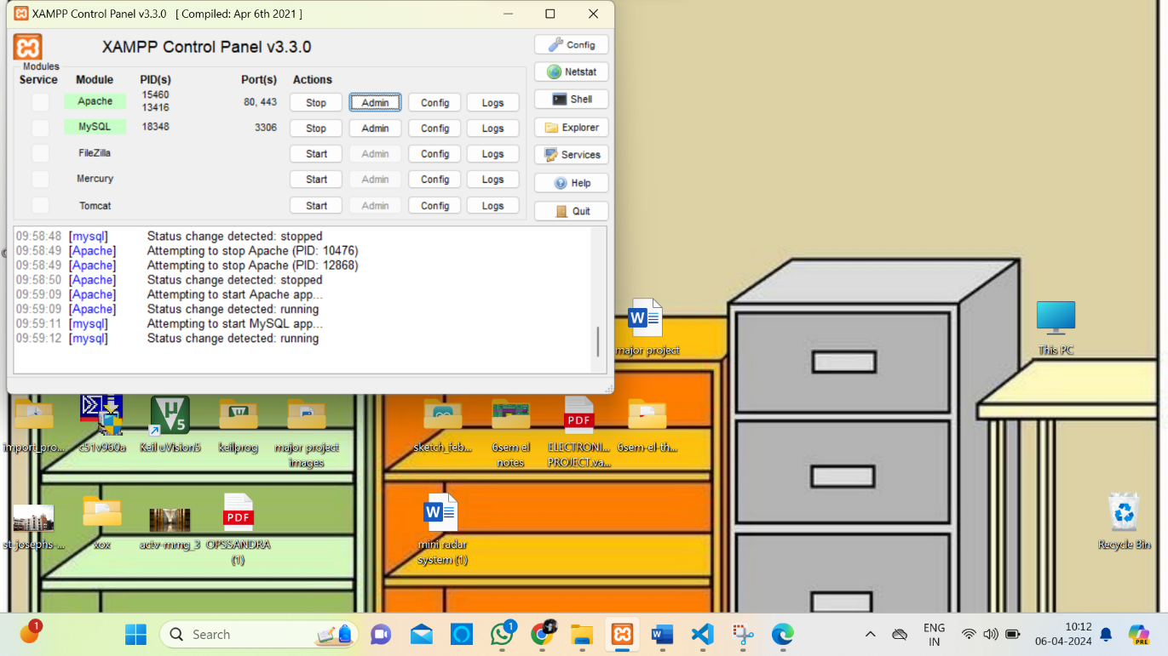

Apache will work on the port-80443
MySQL will work on the port-3306

14:09:00 [main] Initializing Control Panel
14:09:00 [main] Windows Version: Home 64-bit
14:09:00 [main] XAMPP Version: 8.2.12
14:09:00 [main] Control Panel Version: 3.3.0 [ Compiled: Apr 6th 2021 ]
14:09:00 [main] You are not running with administrator rights! This will work for
14:09:00 [main] most application stuff but whenever you do something with services
14:09:00 [main] there will be a security dialogue or things will break! So think
14:09:00 [main] about running this application with administrator rights!
14:09:00 [main] XAMPP Installation Directory: "e:\xampp\"
14:09:00 [main] Checking for prerequisites
14:09:01 [main] All prerequisites found
14:09:01 [main] Initializing Modules
14:09:01 [main] Starting Check-Timer
14:09:01 [main] Control Panel Ready
14:09:03 [mysql] Attempting to start MySQL app...
14:09:04 [mysql] Status change detected: running
14:09:06 [Apache] Attempting to start Apache app...
14:09:06 [Apache] Status change detected: running
09:22:44 [Apache] Attempting to stop Apache (PID: 18684)
09:22:44 [Apache] Attempting to stop Apache (PID: 17136)
09:22:45 [Apache] Status change detected: stopped
09:22:46 [mysql] Attempting to stop MySQL app...
09:22:46 [mysql] Status change detected: stopped
09:22:49 [mysql] Attempting to start MySQL app...
09:22:50 [mysql] Status change detected: running
09:22:51 [Apache] Attempting to start Apache app...
09:22:51 [Apache] Status change detected: running
09:58:48 [mysql] Attempting to stop MySQL app...
09:58:48 [mysql] Status change detected: stopped
09:58:49 [Apache] Attempting to stop Apache (PID: 10476)
09:58:49 [Apache] Attempting to stop Apache (PID: 12868)
09:58:50 [Apache] Status change detected: stopped
09:59:09 [Apache] Attempting to start Apache app...
09:59:09 [Apache] Status change detected: running
09:59:11 [mysql] Attempting to start MySQL app...
09:59:12 [mysql] Status change detected: running

These are the regular condition from the control panel and the timing will change according to its usage time.

FIRST PAGE

FRONTEND:
<!DOCTYPE html>
<html lang="en">
<head>
<meta charset="UTF-8">
<meta name="viewport" content="width=device-width, initial-scale=1.0">
<title>ST JOSEPH’S UNIVERSITY</title>
<style>
/* Basic CSS styles */
body {
font-family: Arial, sans-serif;
margin: 0;
padding: 0;
}
header {
background-color: #333;
color: #fff;
padding: 20px;
text-align: center;
}
#slider {
max-width: 100%;
overflow: hidden;
position: relative;
}
#slider img {
width: 100%;
height: auto;
display: none;
}
#company-info {
text-align: center;
padding: 20px;
margin-bottom: 20px;
}
footer {
background-color: #00ff;
color: #add8e6;
text-align: center;
padding: 5px; /* Reduced padding */
position: fixed;
bottom: 0;
width: 100%;
height: 200px;
}
nav {
background-color: #ffffff;
color: #ffffff;
padding: 10px 0;
text-align: center;
}
nav a {
color: #0000ff;
text-decoration: none;
margin-right: 15px;
}
. content {
padding: 10px;
max-width: 400px;
margin: 0 auto;
}
</style>
</head>
<body>
<header>
<h1>DEPARTMENT OF COMPUTER SCIENCE</h1>
</header>
<nav>
<a href="index1.php">STAFF LOGIN</a>
<a href="timetable.html">TIMETABLE</a>
<a href="syllabus.html">SYLLABAS</a>
<a href="event.html">EVENTS</a>
</nav>
<div id="slider">
<img src="image1.jpg" alt="Image 1">
<img src="image2.jpg" alt="Image 2">
<img src="image3.jpg" alt="Image 3">
<img src="image4.jpg" alt="Image 4">
<!-- Add more images as needed -->
</div>
<div id="company-info">
<h2>About Us</h2>
<p>WELCOME TO ST JOSEPH’S UNIVERSITY, BENGALURU, INDIA.</p>
<p>St Joseph’s University is a Jesuit university at the heart of Bengaluru, the silicon city of India. Established in 1882 by Paris Foreign Mission Fathers, the management of the college was handed over to the Jesuit order (Society of Jesus) in 1937. The college was first affiliated with the University of Madras and later with the Mysore and Bangalore universities. In 1986, St Joseph’s College became the first affiliated college in Karnataka to offer postgraduate programmes. In 1988, it became the first college in Karnataka to get a Research Centre, and in 2005, it was one of five colleges in Karnataka that was awarded academic autonomy. In February 2021, St Joseph's University Bill was presented in the Karnataka Legislative Assembly and was subsequently passed by the Legislative Assembly and Karnataka Legislative Councill. The college received its University status on 2 July 2022 and was inaugurated as India’s first Public-Private-Partnership University by the Honourable President of India, Smt. Droupadi Murmu on 27 September 2022.
As a university, we are dedicated to excellence in education. Over the years, our students have been ranked among the finest in the country, as attested by our illustrious alumni. With an accomplished faculty both in teaching and research, the university is home to leading centres of excellence on campus. Here we try to create leaders for a better world, leaders deeply rooted in our philosophy “Fide et Labore” (a Latin phrase that means "Faith and Toil"), who commit themselves to excel in the fields they choose. We make every effort to be relevant, innovative, and creative. St Joseph’s continues to be a place of deep care for each person, especially those who feel most vulnerable. Join us and be part of this glorious enterprise. </p>
</div>
<footer>
<h2>Contact Us</h2>
<p>Address: st.josephs university</p>
<p>Phone: 080-2221 1429</p>
<p>Email: www.sju.edu.in </p>
</footer>
<script>
// JavaScript for image slider
let index = 0;
const images = document.querySelectorAll('#slider img');
const totalImages = images.length;

function nextSlide() {
images[index].style.display = 'none';
index = (index + 1) % totalImages;
images[index].style.display = 'block';
}

function startSlide() {
setInterval(nextSlide, 2000); // Change slide every 2 seconds
}

startSlide();
</script>
</body>
</html>

RESULT:

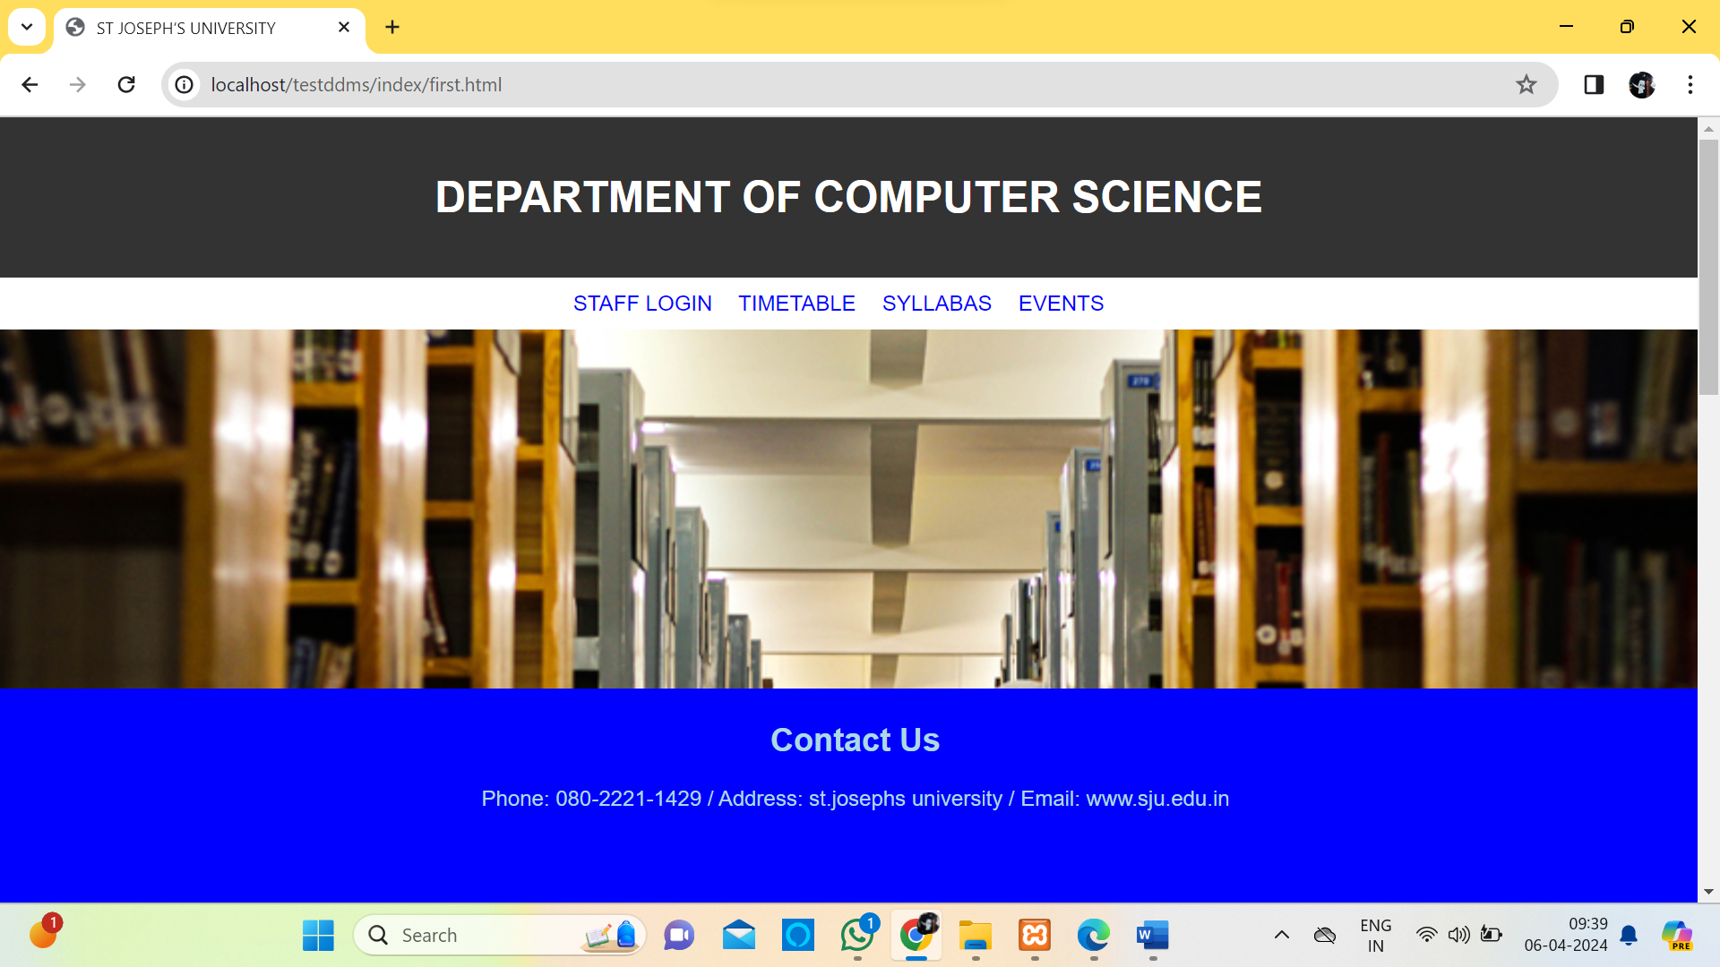

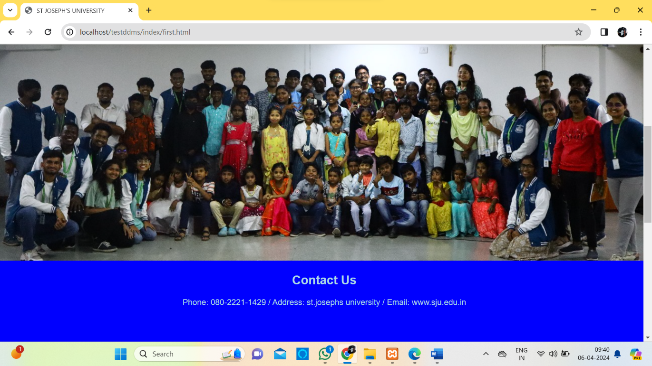

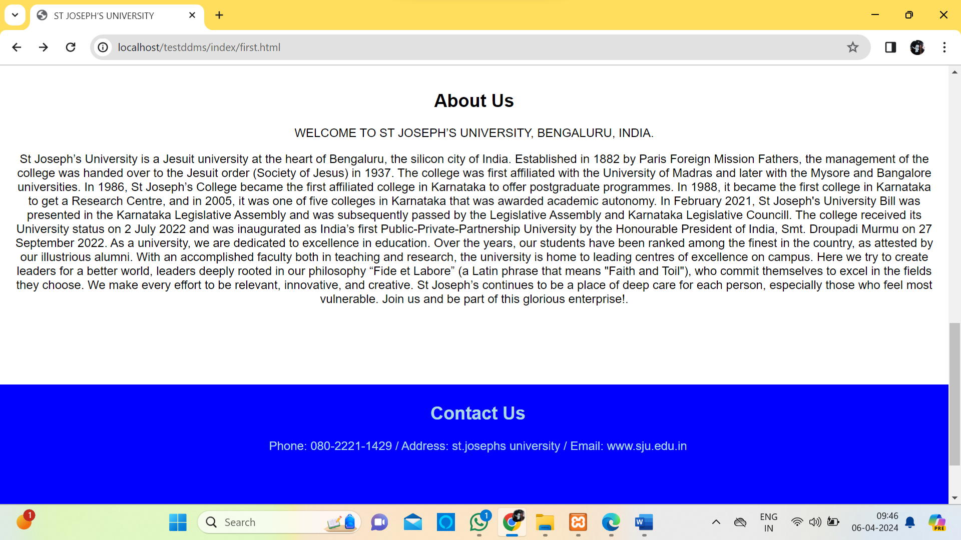

LOGIN PAGE
<!DOCTYPE html>
<html>
<head>
<title>Login Form Design</title>
<link rel="stylesheet" type="text/css" href="style.css">
</head>
<body>
<div class="login-container">
<div class="college-NAME">ST JOSEPHS UNIVERSITY</div>

<form name="myform" onsubmit="return checkLogin()" method="POST">

<p>Username</p>
<input type="text" id="uname" name="uname" placeholder="Enter Username" required>

<p>Password</p>
<div class="password-container">
<input type="password" id="upswd" name="upswd" placeholder="Enter Password" required>

</div>

<button type="submit">Login</button>

<br><br>
<a href="index.html">Register for new account</a>

</form>

</div>

<script>
function checkLogin() {
var username = document.getElementById("uname").value;
var password = document.getElementById("upswd").value;

var users = {
"rajesh": {"password": "raj123$$", "redirect": "RR.php"},
"lennin": {"password": "lennin123$$", "redirect": "LL.php"},
"abdul": {"password": "abdul123$$", "redirect": "AA.php"},
"suman": {"password": "suman123$$", "redirect": "SS.php"}
};

if (users.hasOwnProperty(username) && users[username].password === password) {
window.location.href = users[username].redirect;
return false;
} else {
alert("Invalid username or password. Please try again.");
return false;
}
}
</script>
</body>
</html>

RESULT:

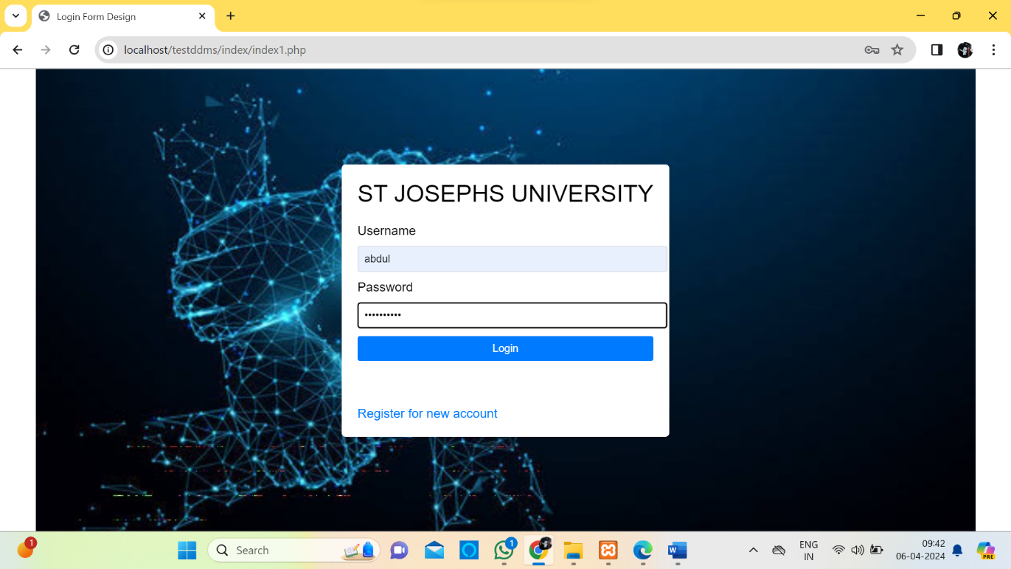

FORGOT PASSWORD
FRONTEND:

<!DOCTYPE html>
<html lang="en">
<head>
<meta charset="UTF-8">
<meta http-equiv="X-UA-Compatible" content="IE=edge">
<meta name="viewport" content="width=device-width, initial-scale=1.0">
<link rel="stylesheet" href="https://cdnjs.cloudflare.com/ajax/libs/font-awesome/5.15.4/css/all.min.css">
<link rel="stylesheet" href="css2.css">
<title>Insert Data</title>
</head>
<body>
<h2> YOUR DETAILS</h2>
<form action="insert.php" method="post">
<label for="first"><i class="fas fa-user"></i> First Name:</label><br>
<input type="text" id="first" name="first"><br>
<label for="last"><i class="fas fa-user"></i> Last Name:</label><br>
<input type="text" id="last" name="last"><br>
<label for="email"><i class="fas fa-envelope"></i> Email:</label><br>
<input type="email" id="email" name="email"><br>
<label for="contact"><i class="fas fa-phone"></i> Contact:</label><br>
<input type="text" id="contact" name="contact"><br>
<label for="collegeID"><i class="fas fa-id-card"></i> College ID:</label><br>
<input type="text" id="collegeID" name="collegeID"><br>
<input type="submit" value="Submit">
</form>

</body>
</html>

RESULT:

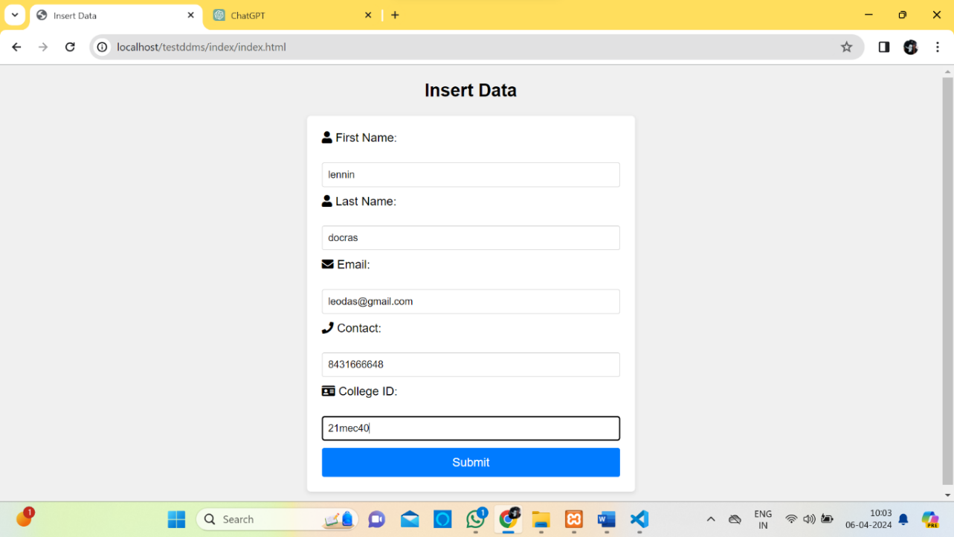

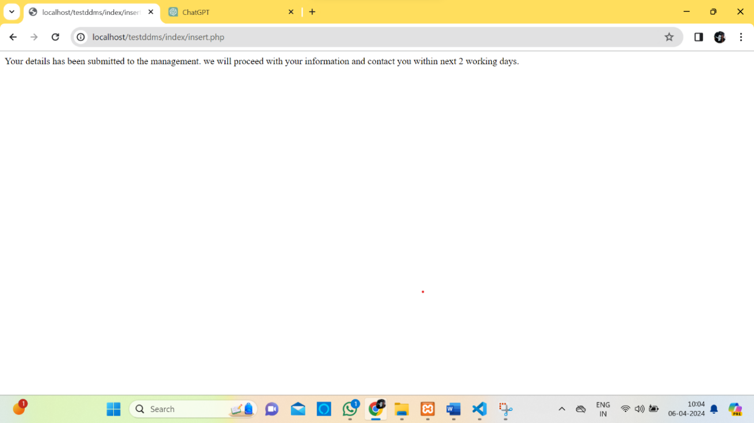

BACKEND:

<?php
$servername = "localhost";
$username = "root";
$password = "";
$dbname = "testddms";

// Create connection
$conn = new mysqli($servername, $username, $password, $dbname);

// Check connection
if ($conn->connect_error) {
die("Connection failed: " . $conn->connect_error);
}

// Get form data
$first = $_POST['first'];
$last = $_POST['last'];
$email = $_POST['email'];
$contact = $_POST['contact'];
$collegeID = $_POST['collegeID'];

// Insert data into table
$sql = "INSERT INTO `index` (`first`, `last`, `email`, `contact`, `collegeID`) VALUES ('$first', '$last', '$email', '$contact', '$collegeID')";

if ($conn->query($sql) === TRUE) {
echo “ Your details has been submitted to the management. we will proceed with your information and contact you within next 2 working days.";

} else {
echo "Error: " . $sql . "<br>" . $conn->error;
}
$conn->close();
?>

RESULT:

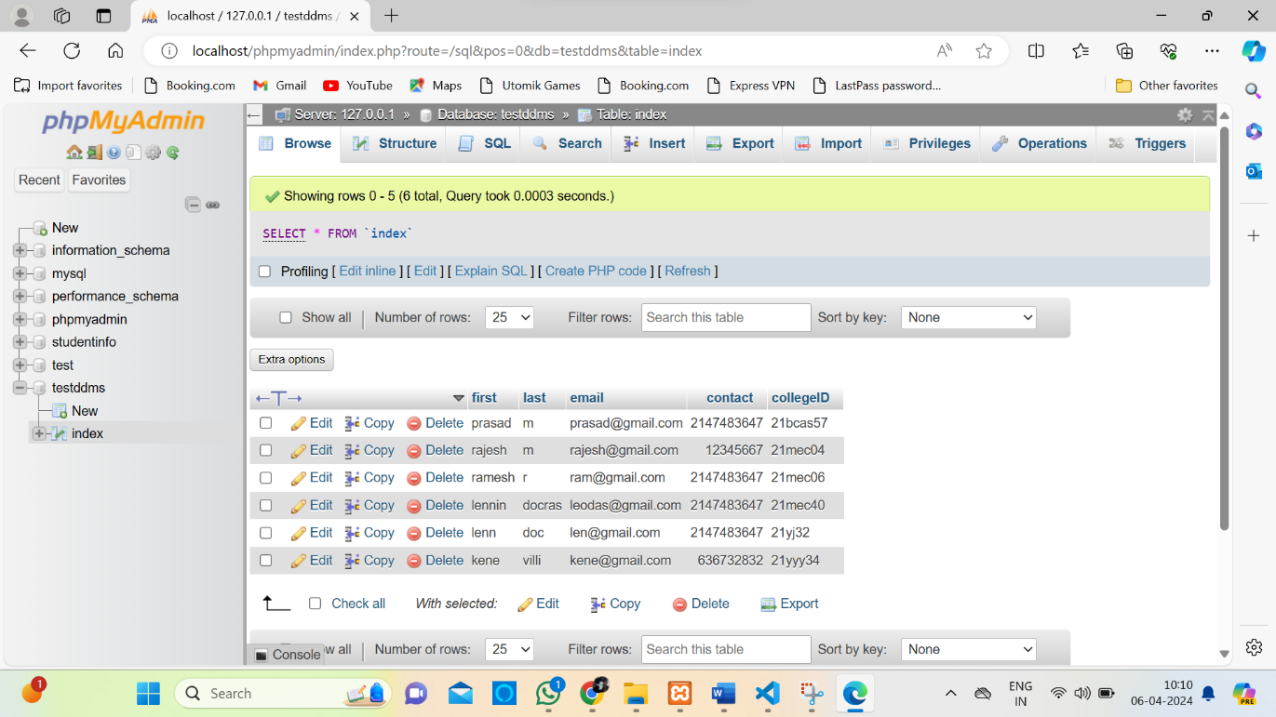

STAFF LOGIN
FRONTEND:

<!DOCTYPE html>
<html lang="en">
<head>
<title>Bootstrap Example</title>
<meta charset="utf-8">
<meta name="viewport" content="width=device-width, initial-scale=1">
<link rel="stylesheet" href="https://maxcdn.bootstrapcdn.com/bootstrap/3.4.1/css/bootstrap.min.css">
<script src="https://ajax.googleapis.com/ajax/libs/jquery/3.7.1/jquery.min.js"></script>
<script src="https://maxcdn.bootstrapcdn.com/bootstrap/3.4.1/js/bootstrap.min.js"></script>
<style>
/* Set height of the grid so .sidenav can be 100% (adjust as needed) */
.row.content {height: 550px}

/* Set gray background color and 100% height */
.sidenav {
background-color: #0af1f5;
height: 100%;
}

/* On small screens, set height to 'auto' for the grid */
@media screen and (max-width: 767px) {
.row.content {height: auto;}
}
</style>
</head>
<body>

<nav class="navbar navbar-inverse visible-xs">
<div class="container-fluid">
<div class="navbar-header">
<button type="button" class="navbar-toggle" data-toggle="collapse" data-target="#myNavbar">
<span class="icon-bar"></span>
<span class="icon-bar"></span>
<span class="icon-bar"></span>
</button>
<a class="navbar-brand" href="#">ST JOSEPHS COLLEGE</a>
</div>
<div class="collapse navbar-collapse" id="myNavbar">
<ul class="nav navbar-nav">
<li class="active"><a href="#">PROFILE</a></li>
<li><a href="https://docs.google.com/spreadsheets/d/1wLRUQWXwakUz3HIwu3_GmhEklR7v5OnRhlp_AF7XGu0/edit?usp=sharing">STUDENT PERFORMANCE</a></li> href="https://docs.google.com/spreadsheets/d/1Iay9QAylQjdggy5E24P8vpBw8p_BLbFosG8SW0c-k6E/edit?usp=sharing">ATTENDANCE</a></li>
</ul>
</div>
</div>
</nav>

<div class="container-fluid">
<div class="row content">
<div class="col-sm-3 sidenav hidden-xs">
<img src="sjulogo.jpg" alt="sjulogo" width="150" height="138">
<ul class="nav nav-pills nav-stacked">
<li class="active"><a href="#section1">PROFILE</a></li>
</ul><br>
</div>
<br>
<img src="rajimage.jpg" alt="rajimage" width="150" height="138">
<div class="col-sm-9">
<div class="well">
<h4>NAME</h4>
<p>RAJESH</p>
</div>
<div class="row">
<div class="col-sm-3">
<div class="well">
<h4>DESIGNATION</h4>
<p>PROFESSOR</p>
<p>(DEPARTMENT OF COMPUTER SCIENCE)</p>
</div>
</div>
<div class="col-sm-3">
<div class="well">
<h4>QUALIFICATION</h4>
<p>BACHELOR OF SCIENCE</p>
</div>
</div>
<div class="col-sm-3">
<div class="well">
<h4>PHONE</h4>
<p>9738378182</p>
</div>
</div>
<div class="col-sm-3">
<div class="well">
<h4>Date of birth</h4>
<p>31/08/2003</p>
</div>
</div>
</div>
<div class="row">
<div class="col-sm-8">
<div class="well">
<p>St.Josephs University,lalbagh road,</p>
<p>shanthi nagar, bengaluru-560027</p>
</div>
</div>
</div>
</div>
</div>
</div>

</body>
</html>

RESULT: Staff login page will differ depending upon who logs in the website. For testing purpose, we have created 4 sample staff logged in pages.

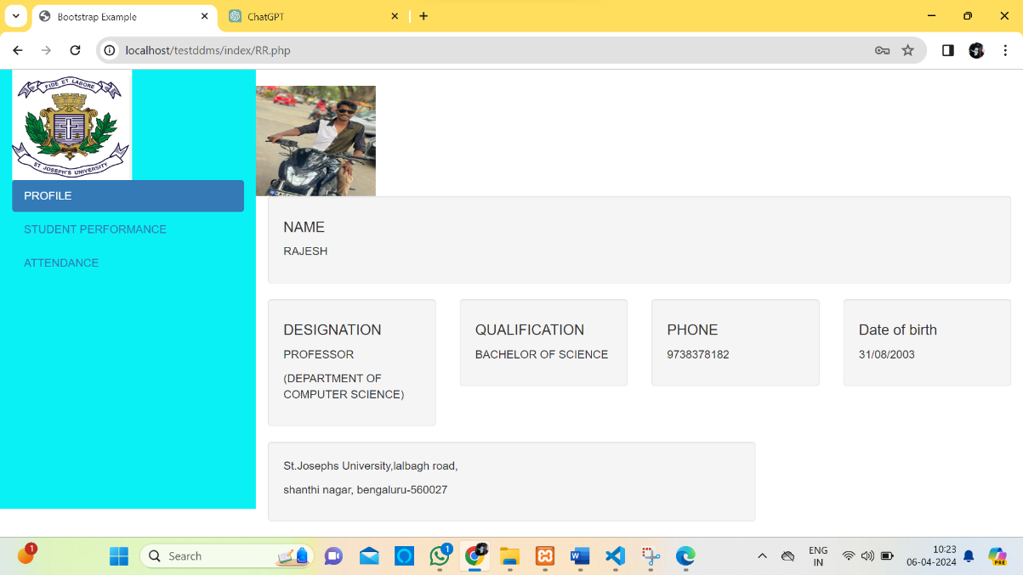

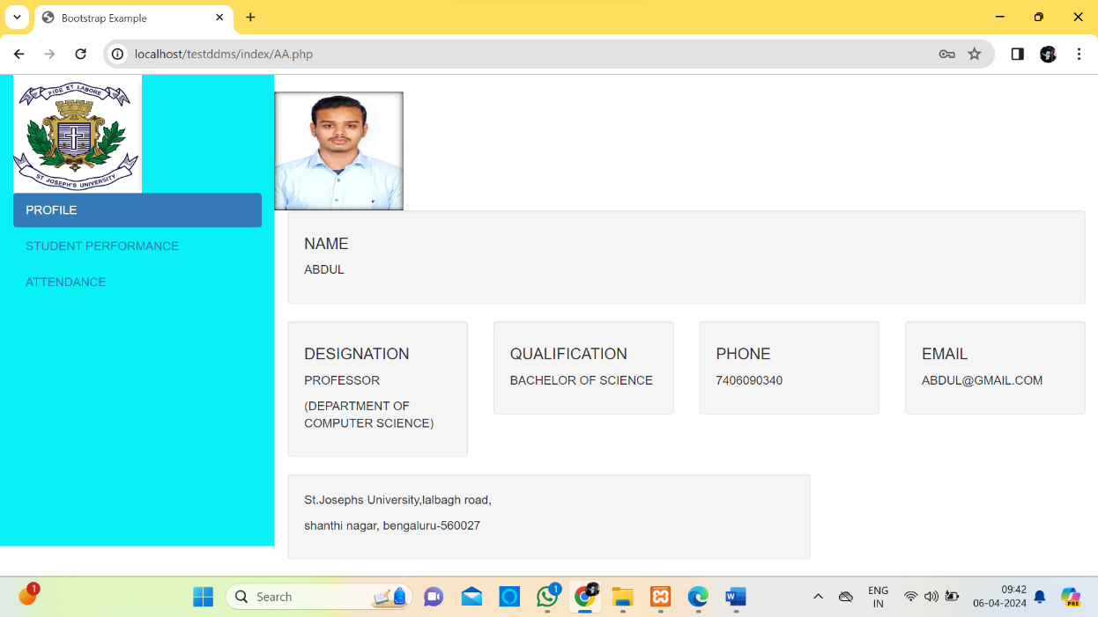

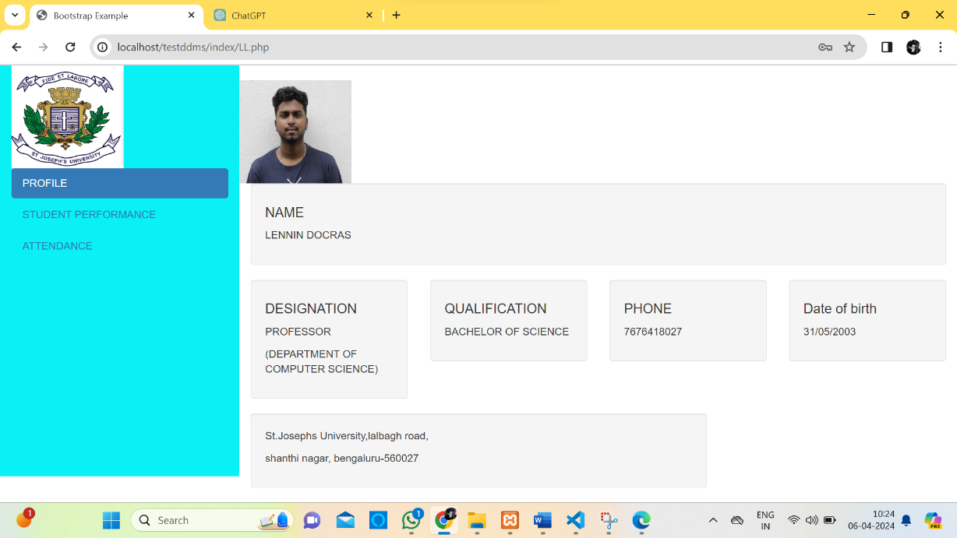

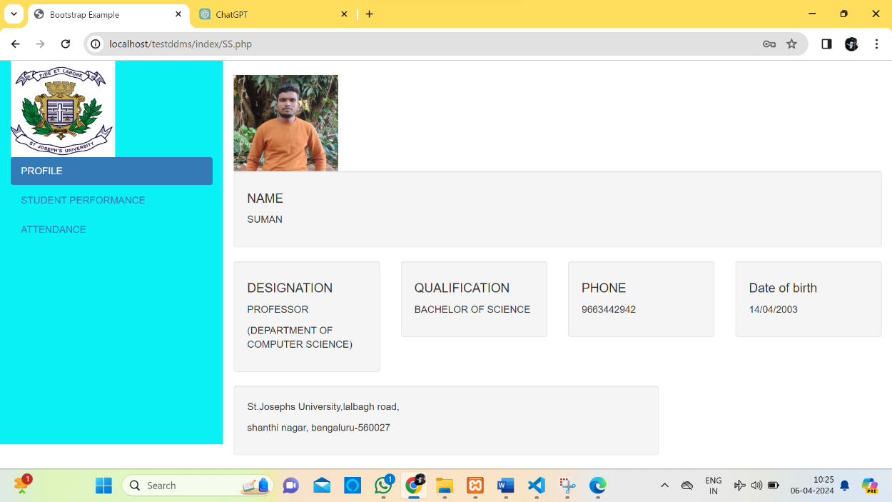

Forget password page works with an external cascaded style sheet named css2.this is the code for that program.

body {
font-family: Arial, sans-serif;
margin: 0;
padding: 0;
background-color: #f0f0f0;
}

h2 {
text-align: center;
margin-top: 20px;
}

form {
max-width: 400px;
margin: 20px auto;
padding: 20px;
background-color: #fff;
border-radius: 5px;
box-shadow: 0 2px 5px rgba(0, 0, 0, 0.1);
}

label {
display: block;
margin-bottom: 5px;
}

input[type="text"],
input[type="email"] {
width: 100%;
padding: 8px;
margin-bottom: 10px;
border: 1px solid #ccc;
border-radius: 3px;
box-sizing: border-box;
}

input[type="submit"] {
width: 100%;
padding: 10px;
border: none;
background-color: #007bff;
color: #fff;
font-size: 16px;
cursor: pointer;
border-radius: 3px;
box-sizing: border-box;
}

input[type="submit"]:hover {
background-color: #0056b3;
}

TIMETABLE

<!DOCTYPE html>
<html lang="en">
<head>
<meta charset="UTF-8">
<meta name="viewport" content="width=device-width, initial-scale=1.0">
<title>Timetable Dashboard</title>
<style>
/* Add your CSS styles here */
body {
background-image: url('syl.jpg');
font-family: Arial, sans-serif;
}
#timetableContainer {
margin-top: 20px;
}
.timetable {
max-width: 100%;
height: auto;
}
</style>
</head>
<body>
<h1>Timetable Dashboard</h1>
<form id="searchForm">
<label for="subject">Select your subject:</label>
<select id="subject" name="subject" required>
<option value="">Select Subject</option>
<option value="EL-CS">EL-CS</option>
<option value="MT-CS">MT-CS</option>
<option value="PH-CS">PH-CS</option>
<option value="ST-CS">ST-CS</option>
<!-- Add more subjects as needed -->
</select>
<button type="submit">Search</button>
</form>
<div id="timetableContainer">
<!-- Timetable images will be displayed here -->
</div>

<script>
document.getElementById('searchForm').addEventListener('submit', function(event) {
event.preventDefault(); // Prevent form submission
var subject = document.getElementById('subject').value.trim().toUpperCase();
var timetableUrl = getTimetableUrl(subject);
if (timetableUrl) {
window.location.href = timetableUrl;
} else {
alert('Timetable not found for the selected subject.');
}
});

// Function to retrieve the timetable URL based on the selected subject
function getTimetableUrl(subject) {
// Sample data, you should replace this with your actual data or logic
var timetableData = {
'EL-CS': 'images/EL-CS.jpg',
'MT-CS': 'images/MT-CS.jpg',
'PH-CS': 'images/PH-CS.jpg',
'ST-CS': 'images/ST-CS.jpg'
// Add more subject-timetable mappings as needed
};
return timetableData[subject];
}
</script>
</body>
</html>

RESULT:
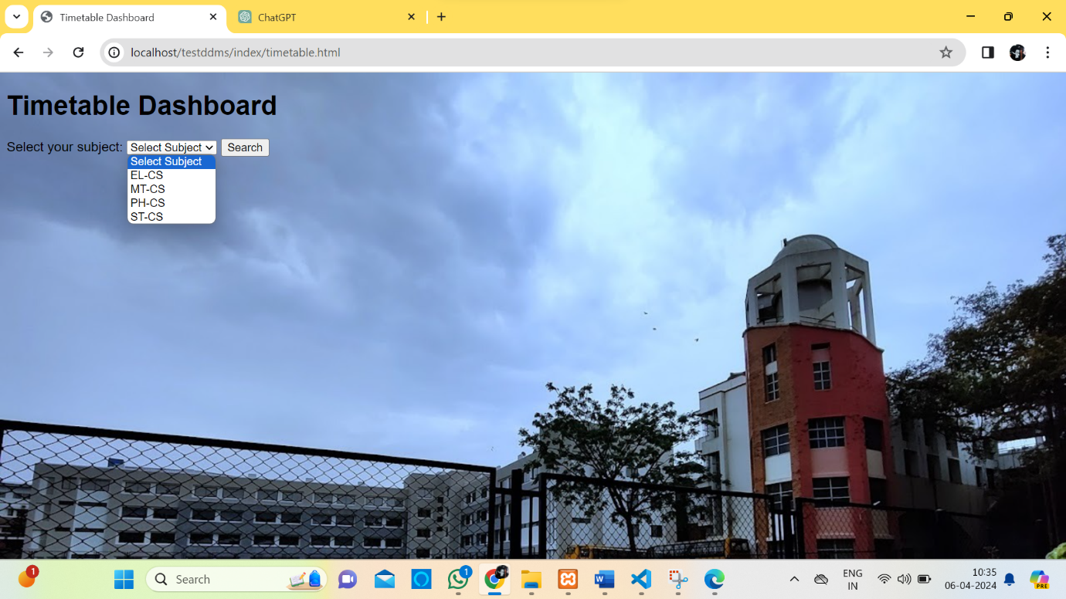

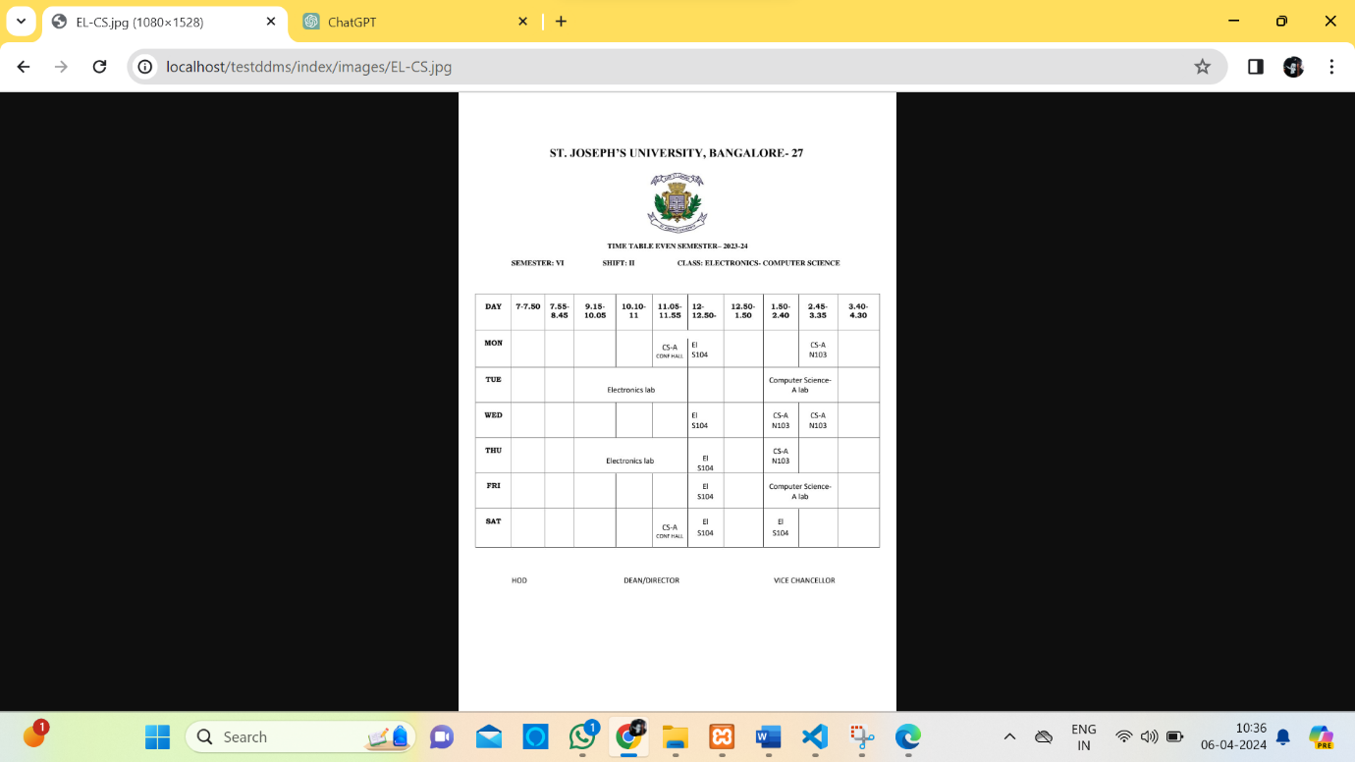

SYLLABUS:
<!DOCTYPE html>
<html lang="en">
<head>
<meta charset="UTF-8">
<meta name="viewport" content="width=device-width, initial-scale=1.0">
<title>SYLLABUS </title>
<style>
/* Add your CSS styles here */
body {
background-image: url('syl.jpg');
font-family: Arial, sans-serif;
}
#timetableContainer {
margin-top: 20px;
}
.timetable {
max-width: 100%;
height: auto;
}
</style>
</head>
<body>
<h1>Timetable Dashboard</h1>
<form id="searchForm">
<label for="subject">Select your subject:</label>
<select id="subject" name="subject" required>
<option value="">Select Subject</option>
<option value="BSC">BSC</option>
<option value="BCA">BCA</option>
</select>
<button type="submit">Search</button>
</form>
<div id="timetableContainer">
<!-- Timetable images or PDFs will be displayed here -->
</div>

<script>
document.getElementById('searchForm').addEventListener('submit', function(event) {
event.preventDefault(); // Prevent form submission
var subject = document.getElementById('subject').value.trim().toUpperCase();
var timetableUrl = getTimetableUrl(subject);
if (timetableUrl) {
window.location.href = timetableUrl;
} else {
alert('Timetable not found for the selected subject.');
}
});

// Function to retrieve the timetable URL based on the selected subject
function getTimetableUrl(subject) {
// Sample data, you should replace this with your actual data or logic
var timetableData = {
'BSC': 'pdfs/BSC.pdf',
'BCA': 'pdfs/BCA.pdf'
// Add more subject-timetable mappings as needed
};
return timetableData[subject];
}
</script>
</body>
</html>

RESULT:

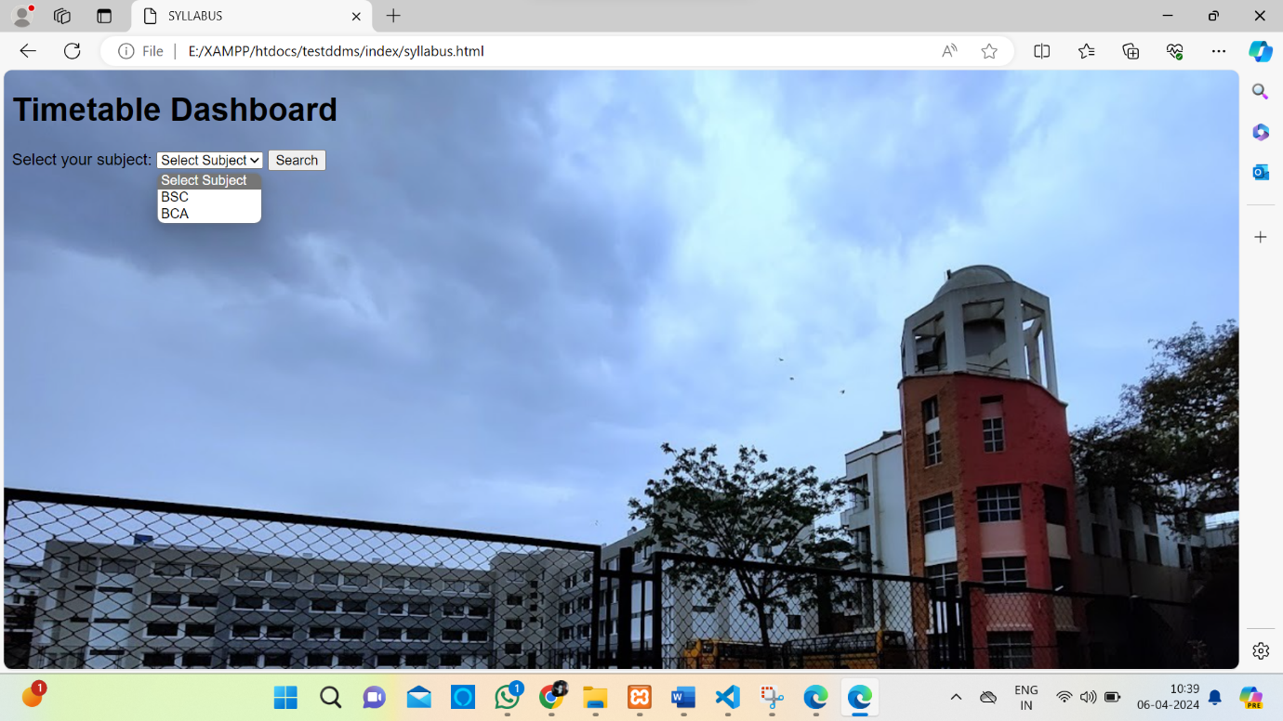

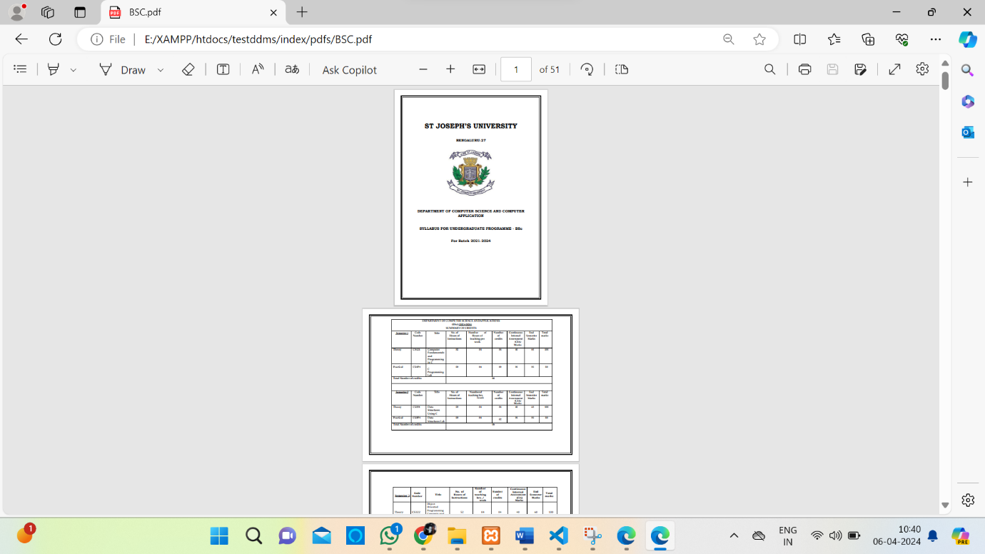

EVENTS:
<!DOCTYPE html>
<html lang="en">
<head>
<meta charset="UTF-8">
<meta name="viewport" content="width=device-width, initial-scale=1.0">
<title>Document</title>
<link rel="stylesheet" href="https://cdnjs.cloudflare.com/ajax/libs/font-awesome/4.7.0/css/font-awesome.min.css">
</head>
<body>

<style>
html{
border: solid #ffd700 5px;

}

body {
margin: 0;
padding: 0;
font-family: Arial, sans-serif;
background: #000435;

}

.box {
width: 55%; /* Adjusted width */
height: 300px;
margin: 50px auto;
background: #edf2f4;
box-shadow: 0 0 10px rgba(0, 0, 0, 0.1);
padding: 20px;
border-radius: 5px;
}
.box img{
width: 100%;
height: 100%;

}
.line{
border: 1px #ffd700 solid;
}
.box1{
height: 150px;
width: 150px;
float: left;
margin: 50px 20px; /* Adjusted margin-top */
margin-left: 100px;
padding: 100px;
border: 1px solid transparent;
background: white;

}
.btn {
border-radius: 100px;
margin-left:700px;
border: 1px solid transparent;
margin-top: 10px;
background-color: DodgerBlue;
border: none;
color: white;
margin: 0;
position: absolute;
top: 85%;
left: 42%;
padding: 30px 50px;
transform: translateY(-50%);
cursor: pointer;
font-size: 20px;

}
.btn:hover {
background-color: RoyalBlue;
}
.btn1{
background-color: DodgerBlue;
color: white;
float: left;
font-size: 20px;
align-items: center;
border-radius: 30px;
margin-left: 190px;
margin-bottom: 150px;
padding: 30px 50px;

}
.btn1:hover {
background-color: RoyalBlue;
}

.footer {
background-color: transparent;
padding: 20px;
margin-top: 500px;
position: absolute;

width: 100%;
}
.footer p {
color: white;
font-size: 18px;
text-align: center;

}

</style>
<center>
<h1 style="font-size: 40px; font-weight: 800; color: white">
DEPARTMENT OF COMPUTER SCIENCE
</h1>
</center>
<div class="line"></div>
<p style="color: white; text-align: center; font-size: 24px;">🌟 Welcome, Josephites! 🌟<br>
Get ready to embark on an exciting journey filled with knowledge, creativity, and endless possibilities!<br>
We are thrilled to invite you to three extraordinary events designed exclusively for you, our talented Josephites</p>
<div class="box">
<img src="SYNTAXIA.jpg" alt="img">
</div>
<button class="btn" id="go4"><i class="fa fa-download"></i> BROCHURE</button>
<br>
<br>
<br>
<h1 style="font-size: 40px;font-weight: 800; color: white; margin-left: 50px; margin-top: 80px;" >UPCOMING EVENTS...</h1>
<div class="box1" style=" background-image: url(exodous.png); background-size:cover; background-position:center; background-repeat:no-repeat; "></div>
<div class="box1" style=" background-image: url(technophite1.png); background-size:cover; background-position:center; background-repeat:no-repeat; "></div>
<button class="btn1" id="go1" style="margin-left: 190px; margin-right: 120px;" ><i class="fa fa-eye"></i> View</button>
<button class="btn1" id="go2" style="margin-right: 110px;"><i class="fa fa-eye"></i> view</button>

<br>
<br>
<br>
<br>
<div class="footer">
<p>
Join us as we come together to celebrate innovation, explore the wonders of technology, and connect with like-minded individuals.<br>
Your presence is key to making these events truly memorable, so mark your calendars and prepare to be inspired!<br>
See you there, Josephites!
</p>
</div>

<script>

var go1 = document.getElementById("go1");
var g02 = document.getElementById("go2");
var g03 = document.getElementById("go3");
var g04 = document.getElementById("go4");

go1.addEventListener("click", function(){
window.location.href = "https://drive.google.com/file/d/1WHLf8kgeTUf7cgdkcSsp1zqRPWboYr0v/view?usp=sharing";
});

go2.addEventListener("click", function(){

window.location.href = "https://drive.google.com/file/d/1Kadw6-OLkzM4ukVZxJpqkMDV32A5u-R_/view";
});
go3.addEventListener("click", function(){

window.location.href = "https://drive.google.com/file/d/1uwH-3BJL7tOdUHHIdgSRfkY3Q05Ehm_H/view?usp=sharing";
});
go4.addEventListener("click", function(){

window.location.href = "https://drive.google.com/file/d/1GqE8MZHNXHidhyxrjjOcaJJ2e7fGJ4iX/view?usp=sharing";
});

</script>
</body>
</html>

RESULT:

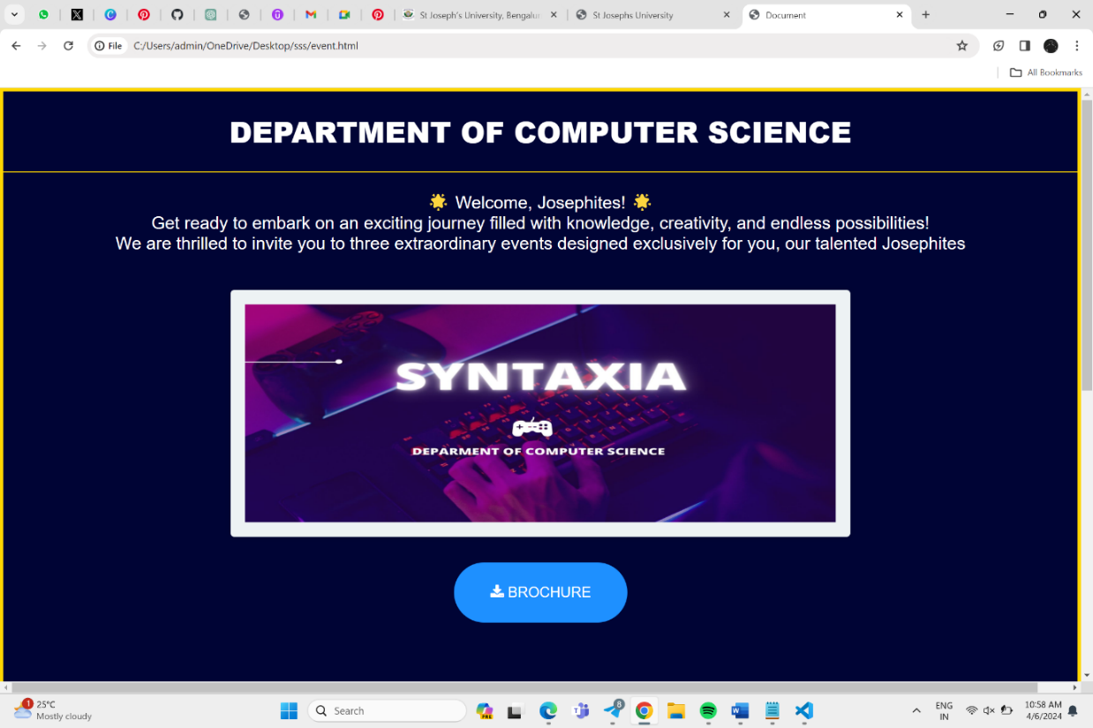

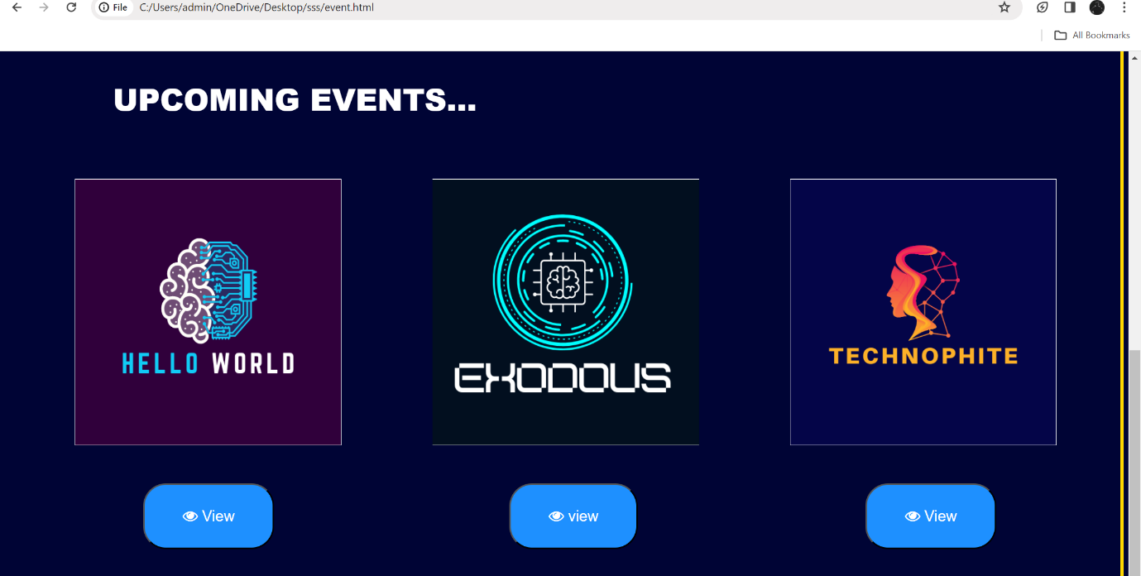

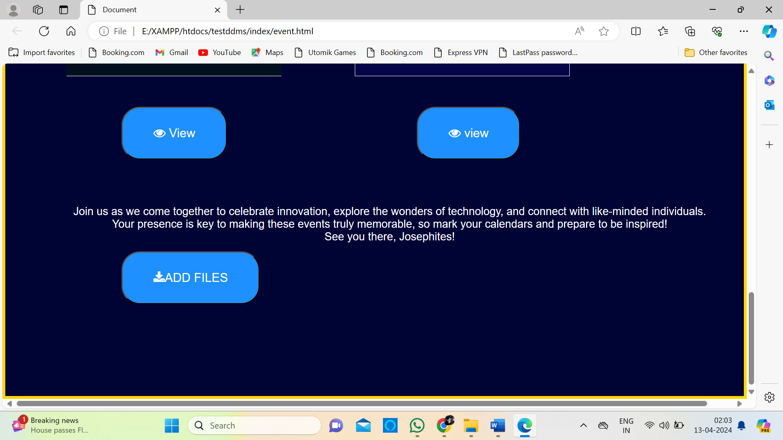

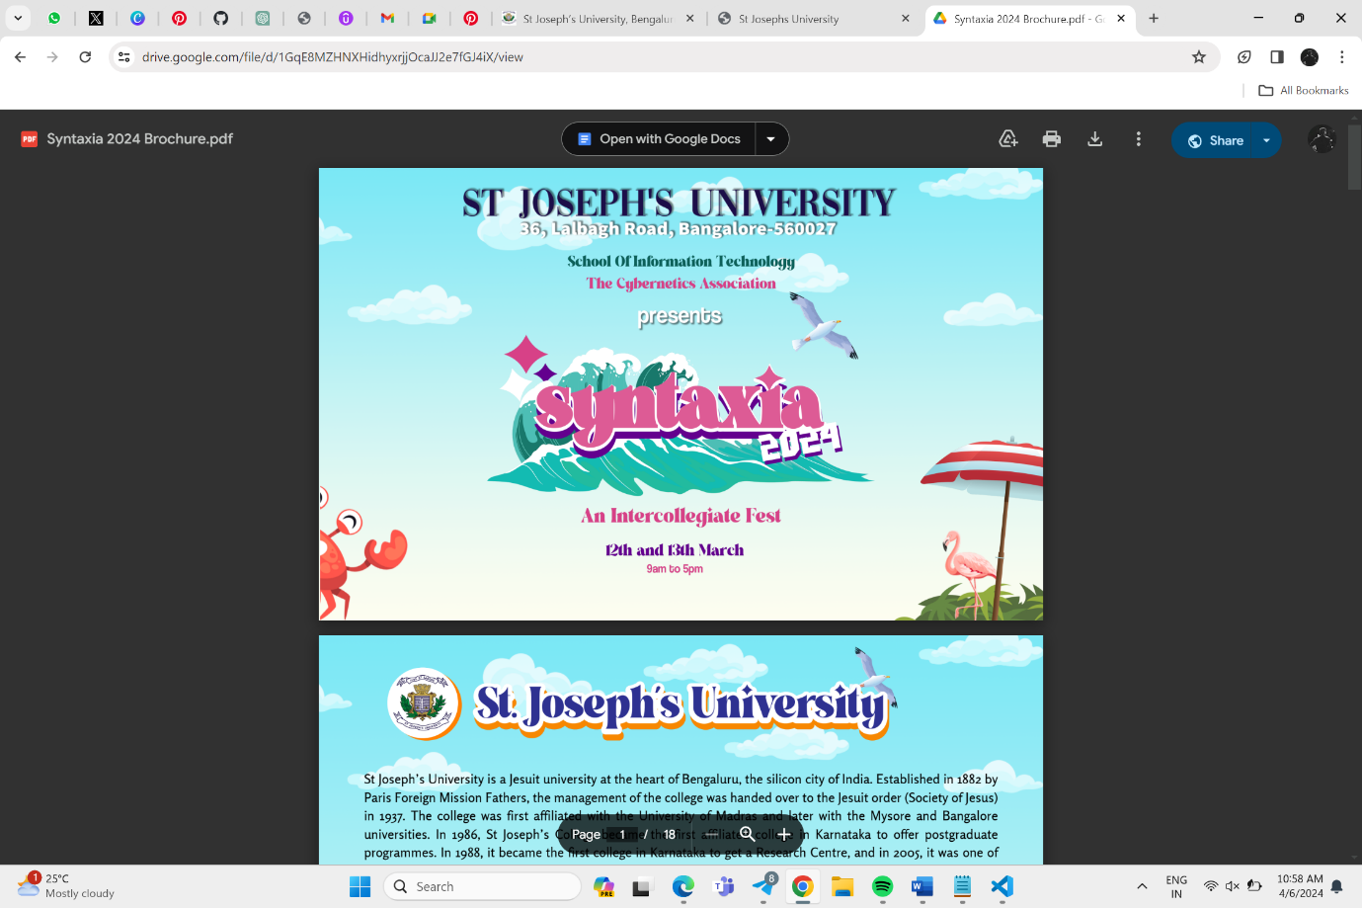
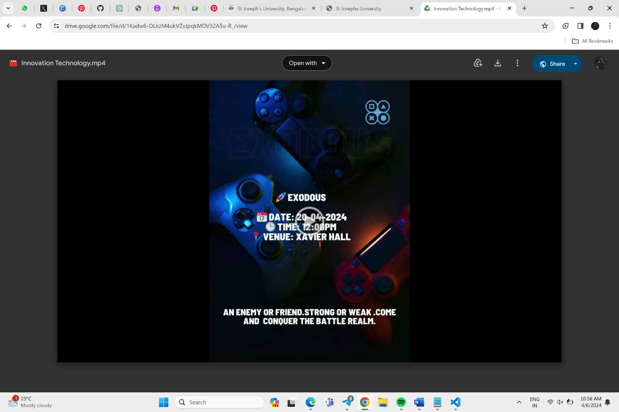

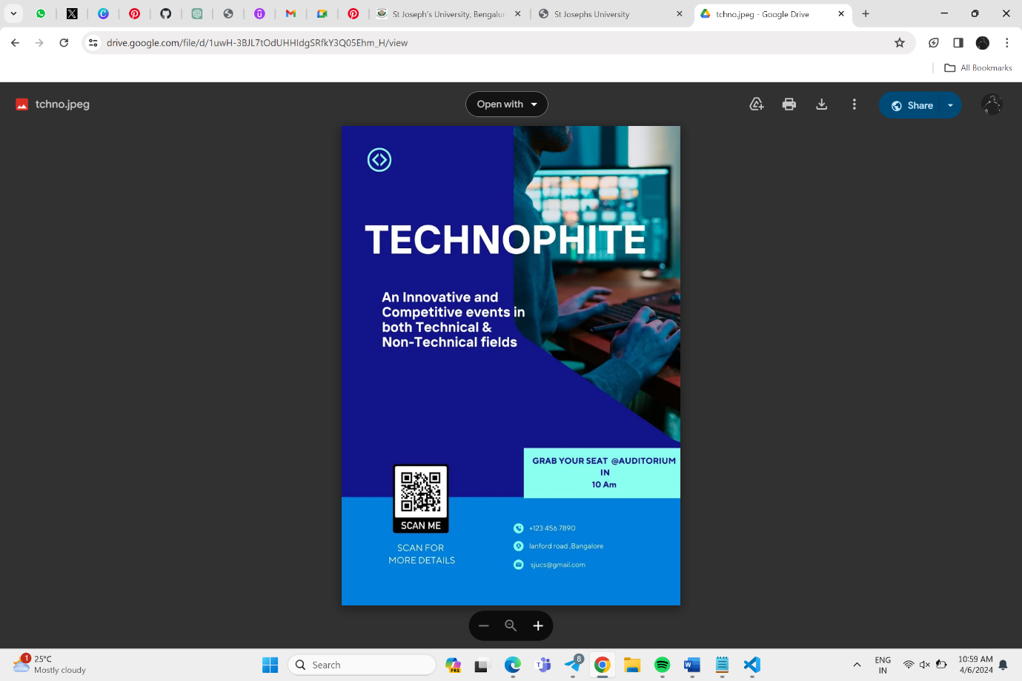

ATTENDANCE AND STUDENT PERFORMANCE HAS BEEN REDIRECTED TO EXCEL SHEETS IN GOOGLE DRIVE.

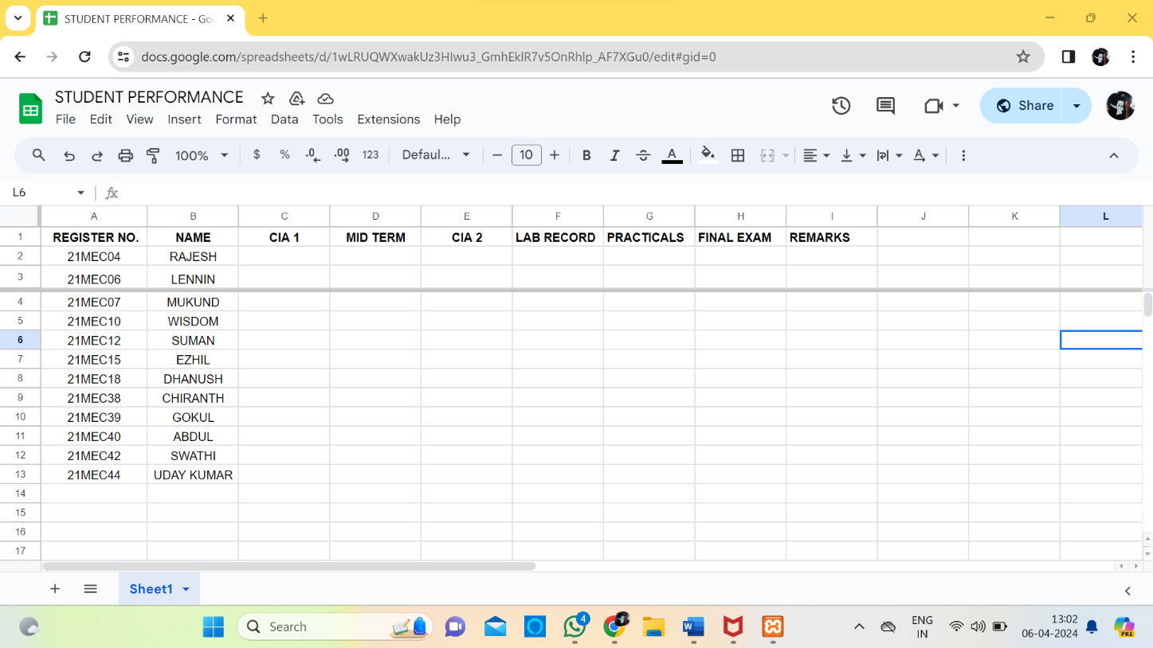

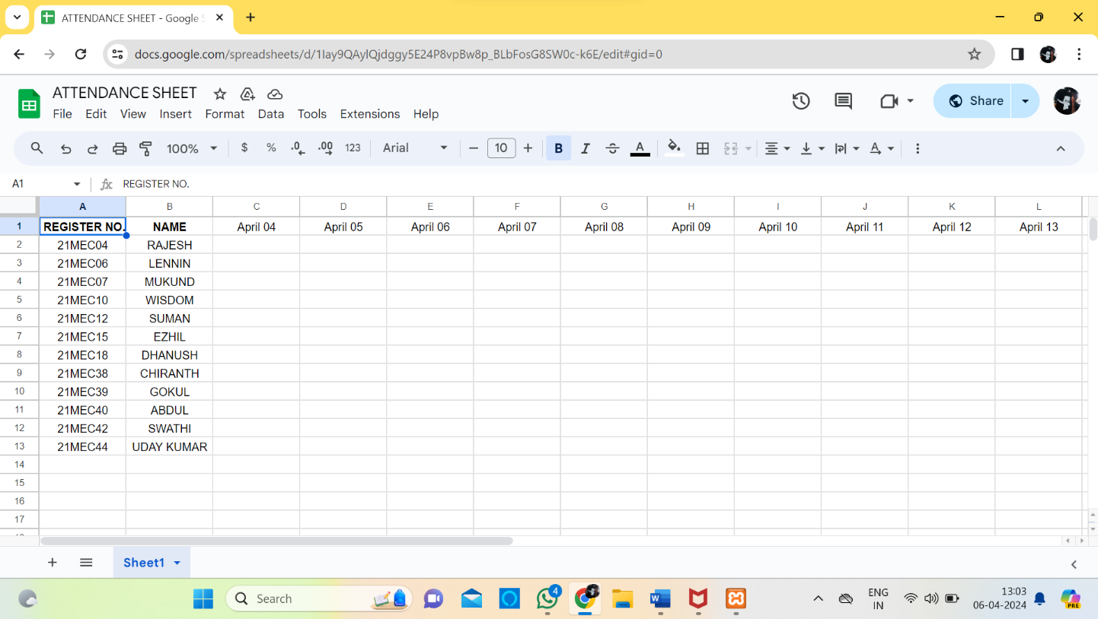

Future Enhancement
- Integration with AI:
The integration of artificial intelligence (AI) technologies stands as a pivotal advancement for the Department Document Management System (DDMS). Implementing AI, particularly natural language processing (NLP) and machine learning (ML) algorithms, can revolutionize document categorization, indexing, and search functionalities. By analyzing document content and user behavior, AI can offer personalized document recommendations, improve search accuracy, and automate tedious tasks like metadata tagging. Additionally, AI can assist in identifying trends and patterns within document usage, providing valuable insights for decision-making and process optimization.

- Enhanced Security Features:
As document security remains a top priority, future enhancements should include robust security measures. Integrating blockchain technology for document storage and verification can ensure tamper-proof records, enhancing data integrity and authenticity. Furthermore, incorporating biometric authentication methods, such as fingerprint or facial recognition, can bolster user security by adding an extra layer of verification.

- Mobile Application: Developing a mobile application for the DDMS can significantly enhance user accessibility and convenience. The mobile app can provide a seamless interface optimized for smaller screens, enabling users to access, edit, and manage documents from anywhere, at any time. Features such as offline access, push notifications for document updates, and integration with device features like cameras for document scanning can further enhance the user experience. Integration with Cloud Services: Integrating the DDMS with cloud storage services like Google Drive or Dropbox can offer several benefits. Cloud storage provides scalability, ensuring that the system can accommodate growing document storage needs. It also facilitates easy access to documents from multiple devices and locations, enhancing collaboration and productivity. Additionally, cloud services often offer advanced security features and data redundancy, ensuring document safety and availability.

- Enhanced Collaboration Tools: To facilitate seamless collaboration among users, future enhancements can include advanced collaboration tools. Real-time document editing capabilities, similar to Google Docs, can enable multiple users to collaborate on a document simultaneously. Integration with video conferencing tools and task management features can further streamline teamwork and improve productivity.

Conclusion
The Department Document Management System (DDMS) represents a significant step forward in modernizing document management practices within the college computer department. By leveraging digital solutions and advanced technologies, the DDMS offers a comprehensive platform for storing, retrieving, and managing documents, streamlining departmental operations and improving efficiency.
Looking ahead, the integration of AI, enhanced security features, mobile application development, cloud service integration, advanced collaboration tools, and data analytics capabilities can further enhance the functionality and usability of the DDMS. These enhancements can ensure that the DDMS remains a cutting-edge solution for document management needs, meeting the evolving requirements of the college computer department and enhancing overall organizational efficiency.
Data Analytics and Reporting: Implementing data analytics capabilities within the DDMS can provide valuable insights into document usage patterns and user behaviors. By analyzing this data, administrators can make informed decisions regarding document management strategies, user training needs, and system improvements. Additionally, automated reporting tools can generate customizable reports on document access, edits, and trends, aiding in compliance and auditing processes.

Bibliography

- Login page- https://youtu.be/ViY4cweNs54?si=jigdmAUGDiMCztgw
- Backend connection- https://youtu.be/WmFHreVid-k?si=EVrgr2LTxK7E3a81
- https://youtu.be/PJyECHL3-3Y?si=AvPoxKO8HoZ1OMu3
- For general information- https://en.wikipedia.org/wiki/Document_management_system
https://www.ibm.com/topics/document-management
- Bookstrap for CSS follow links- https://getbootstrap.com/
- Layout and module References from St Josephs university Linways
- Chat bot (chat GPT) for codes

Applications
- Visual studio code 2008
- Xampp control panel
- Google chrome and drive
- Lucidchart (website for design diagrams)

